**Getting Access to Boardex and Execucomp on WRDS 010322**

# General Links

* Datasets I have access to: <https://wrds-www.wharton.upenn.edu/users/products/>
* My Web Queries: <https://wrds-www.wharton.upenn.edu/query-manager/query-listing/>
* My Account: <https://wrds-www.wharton.upenn.edu/users/your-account/>

# Boardex

* Description: Access educational background, prior employment, and connections of **directors and executives**. Analyze the proportion of politically connected directors, using CEO-level controls such as age, gender, and experience. Extract executive stock option holdings.
* Vendor: <https://wrds-www.wharton.upenn.edu/pages/about/data-vendors/boardex/>

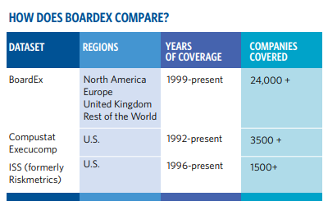

* Get Data Page: <https://wrds-www.wharton.upenn.edu/pages/get-data/boardex/>
* Get Data Page (Sample): <https://wrds-www.wharton.upenn.edu/pages/get-data/boardex-trial-sample/>
* Access: No access to Boardex (boardex_eur, boardex_na, boardex_row, boardex_uk), only have access to BoardEx Trial / Sample (boardex_trial).
* Data Dictionary: <https://wrds-www.wharton.upenn.edu/data-dictionary/boardex_trial/>
* Overview of Boardex data: <https://wrds-www.wharton.upenn.edu/pages/support/manuals-and-overviews/boardex/wrds-overview-boardex-data/>
* Path(s) on WRDS Cloud: /wrds/samples/sasdata/boardex/*.*
* Sample Queries:

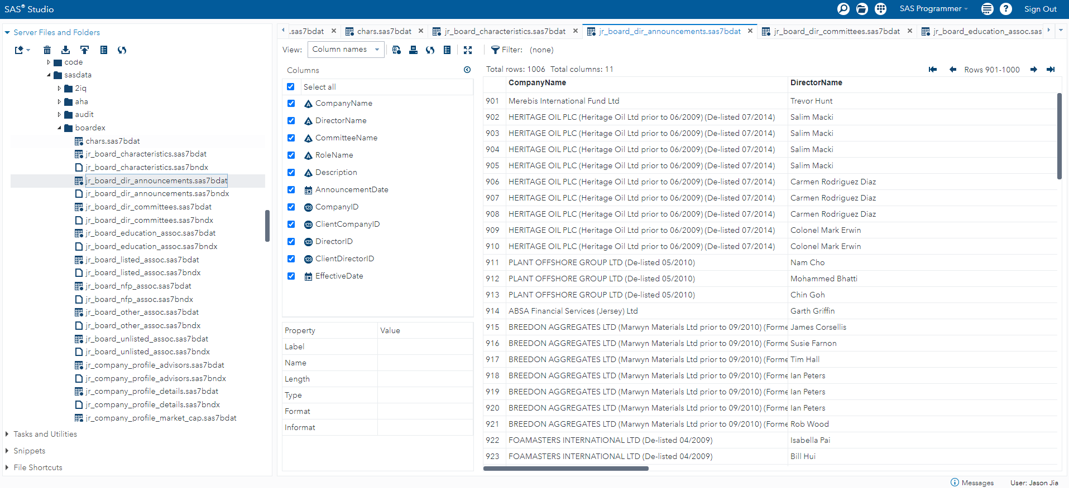

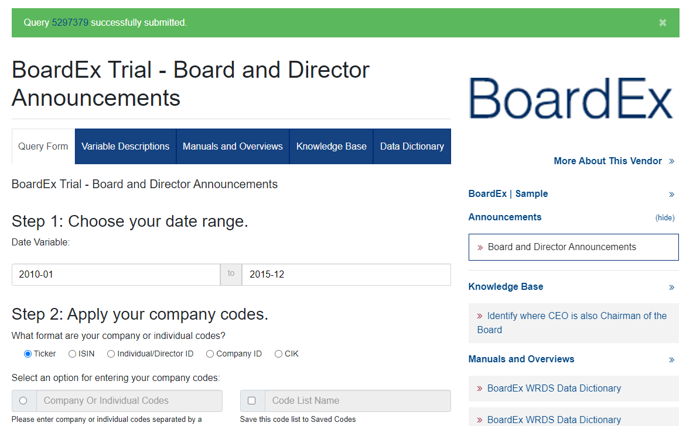

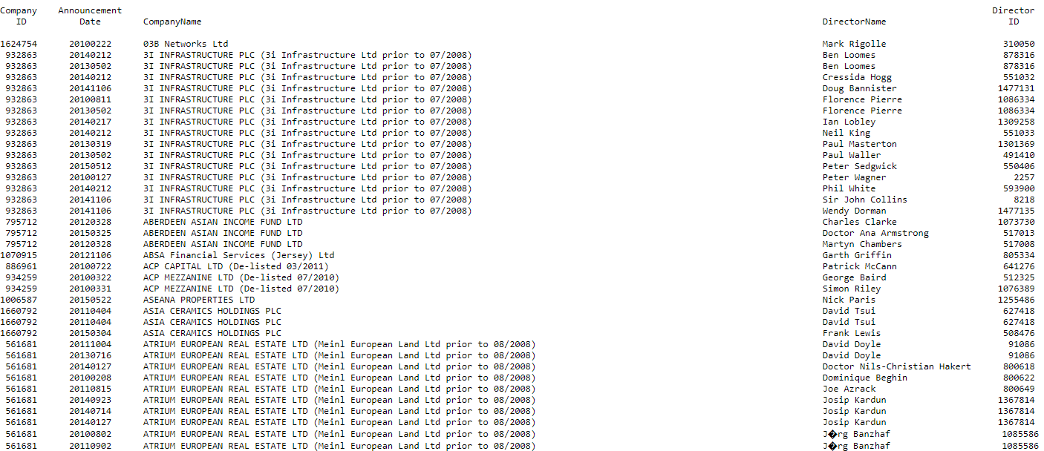

# Compustat ExecuComp

* Description: Compustat Execucomp from S&P Global provides **executive** compensation data collected directly from each company’s annual proxy (DEF14A SEC form). Detailed information on salary, bonus, options and stock awards, non-equity incentive plans, pensions and other compensation items are available.
  + Data is available since 1992. Accounting rules change over time, especially in 2006 with FAS 123R, causing some variables to be discontinued and others to appear. The main compensation items do have continuity.
  + Since 2006, Execucomp data is delivered in 6 main tables, mapping the “original” tables in the annual proxy.
    - AnnComp – Summary compensation data + other.
    - PlanBasedAwards – Contains data on awarded options and stock grants during the filled fiscal year.
    - OutstandingAwards – Describes the outstanding stock options and unvested stock awards held by officers as of the end of fiscal year.
    - DeferredComp – Contains deferred compensation.
    - Pension – Contains all details on pension benefits.
    - DirectorComp – Contains new details on the director compensation.
  + Two additional tables from pre-FAS123 are provided:
    - Stgrttab – Contains details on Stock Options Grants Pre-FAS123.
    - Ltawdtab – Contains Long Term Incentive Plan Awards Pre-FAS123.
* Vendor: <https://wrds-www.wharton.upenn.edu/pages/about/data-vendors/sp-global-market-intelligence/>
* Get Data Page: <https://wrds-www.wharton.upenn.edu/pages/get-data/compustat-capital-iq-standard-poors/compustat/execucomp/>
* Access: Access to Compustat ExecuComp (comp_execucomp)
* Data Dictionary: <https://wrds-www.wharton.upenn.edu/data-dictionary/comp_execucomp/>
* Links to guides:
  + <https://wrds-www.wharton.upenn.edu/pages/support/manuals-and-overviews/compustat/execucomp/>
  + <https://wrds-www.wharton.upenn.edu/pages/grid-items/compustat-execucomp-basics/>
  + <https://wrds-www.wharton.upenn.edu/pages/classroom/introduction-execucomp/>
  + <https://wrds-www.wharton.upenn.edu/pages/support/manuals-and-overviews/compustat/execucomp/overview-executive-compensation/>
* Path(s) on WRDS Cloud: /wrds/comp/sasdata/execcomp/*.*
* Sample Queries:

